Science Taster Day – Engineering
Build a Light Dependent 555 Astable Oscillator – Here is the Component Layout
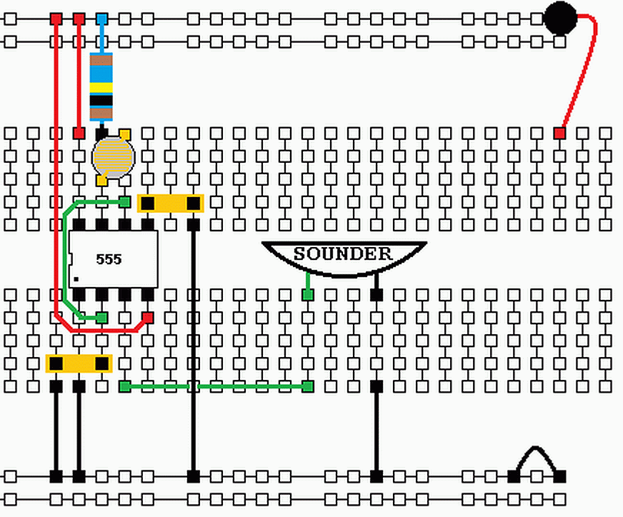
Layout Photo
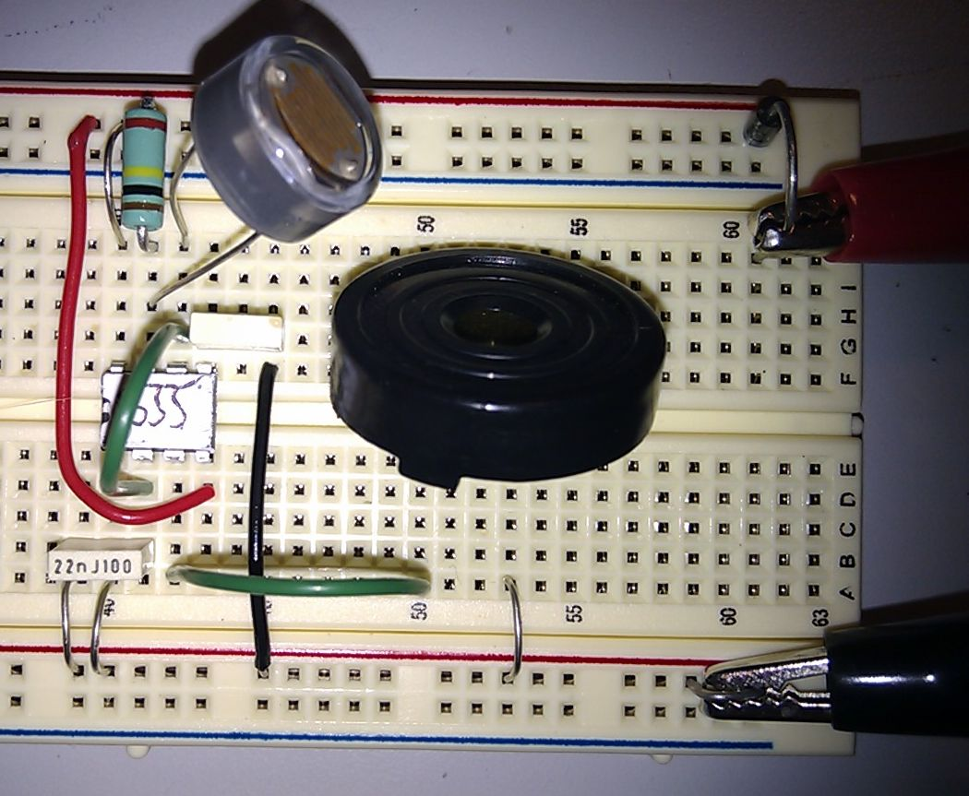
555 Timer Astable – Buzzer
- This circuit uses a CAPACITOR.
This is like an electronic bucket.
It’s repeatedly filled and emptied.
- The two RESISTORS control how quickly the CAPACITOR fills and empties.
- The light dependent resistor (LDR) makes it possible to play a tune by shading the light.
- The 555 Timer fills the CAPACITOR until it’s 2/3 full.
Then it empties it until it’s 1/3 full.
This repeats for ever.
- The 555 Timer also drives the SOUNDER.
- The DIODE passes current in one direction only.
If you wire up the power the wrong way round, this protects the circuit.

